Working with ICPSR
NOTE: ICPSR provides various file formats. Some data sets open easily and others require more steps. Always save files to your P:drive. It’s also a good idea to have SPSS open in case you need it before you start downloading from ICPSR.
- Open the database and search for your topic
- Once you have opened the file you can click on the Quick Download button in green if there is one available for the item. Select the delimited file option if it’s available for the quickest access to the data. A log-in screen will come up. If you haven’t created an account you will need to do that before it will let you continue. Next a screen will come up that covers licensing and use of the data. Go to the bottom of the page and click I accept.
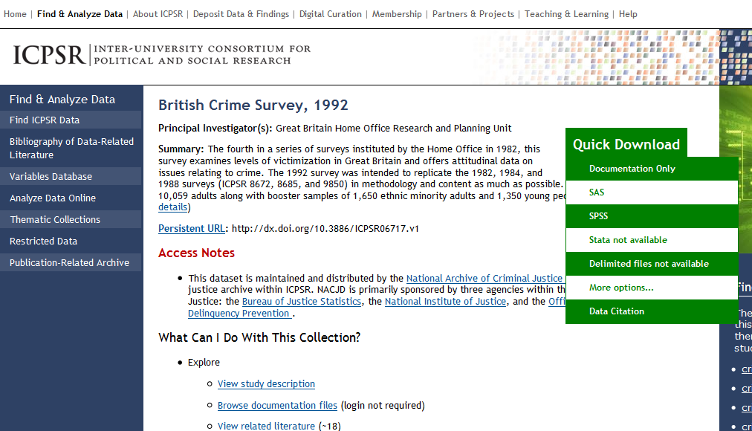

- OR scroll down the page to the Download section and choose open selected files

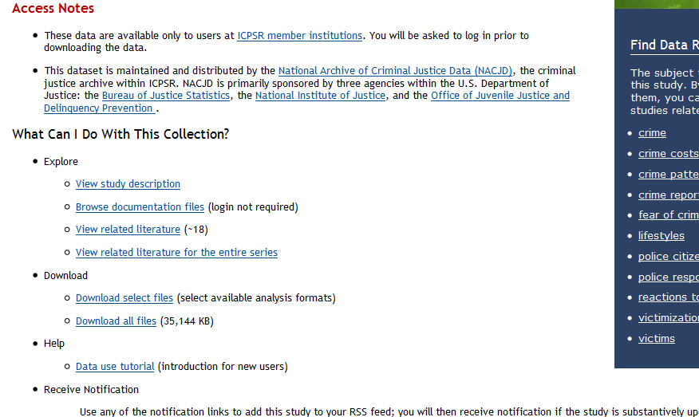

- The window should look like this. Again, select delimited if it’s available and then save the file to your P: drive and open in Excel. In this example the delimited file is not available so you will want to click on SPSS in the All Datasets line. You will need to log in to continue and download the data.
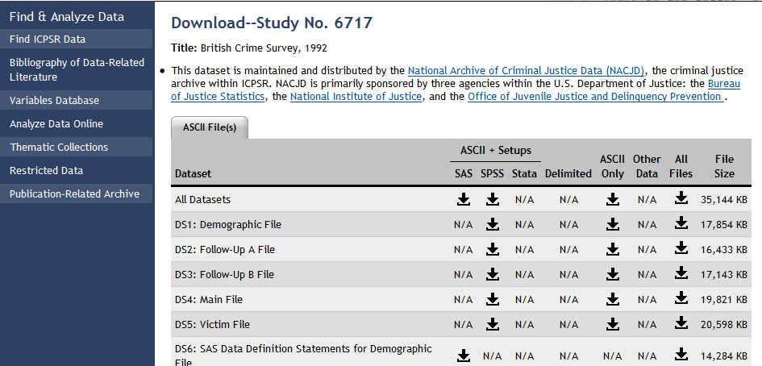

- Most of these files are zipped. Right click on the item and click extract all. Make sure you save these to your P: drive or portable drive and rename to something you can easily recognize. They will be much easier to work with.

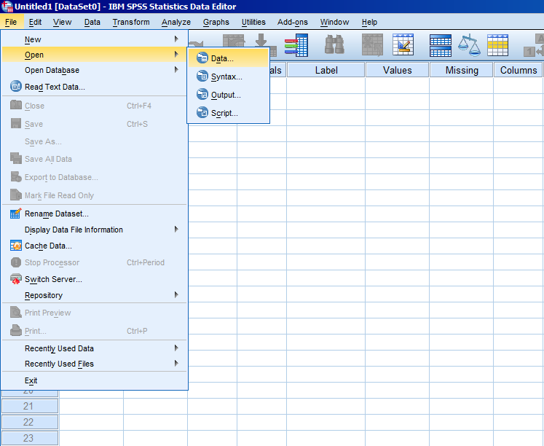

You may find a variety of files and formats. The codebook is usually a .pdf and contains information about the study and data collection along with copies of the Questionnaire and other supporting documents. If a .pdf is not available, try using WordPad to open.

To access the data
- For .por (SPSS portable file) or tab delimited files use SPSS to open the files like an Excel document.
- .sav are SPSS files and can just be clicked to open up.
- For non SPSS files select Save As, choose SPSS files and resave. It’s a good idea to rename the file something that is more recognizable to you.

- Another scenario you may encounter is two distinct files. One will be called Data and the other Setup. These need to be combined in a multi-step process.
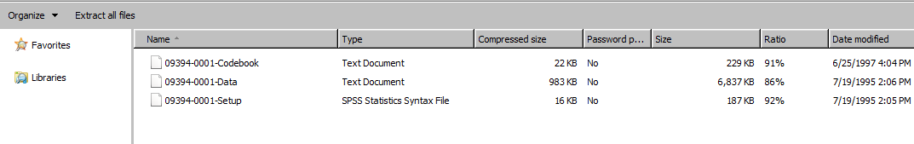

The next few screen shots outline exactly how to do this.

Instruction for Retrieving and Opening Data in SPSS from ICPSR
(when there is a Setup/SPSS syntax file and a Data/.txt file in the download)
- Search and select the data/survey of interest.
- Scroll down and click on the “Download Select Files” link.
- Click the Arrow under “SPSS” for “All Data Sets” if available. Accept the Terms of Use on the following page.
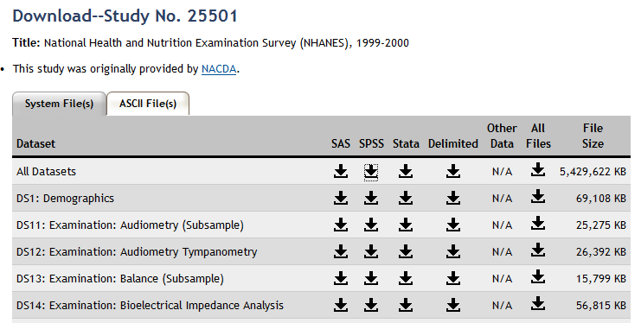
- Click “download your files here” and select “Save”. Save somewhere on your P: Drive or a flash drive.
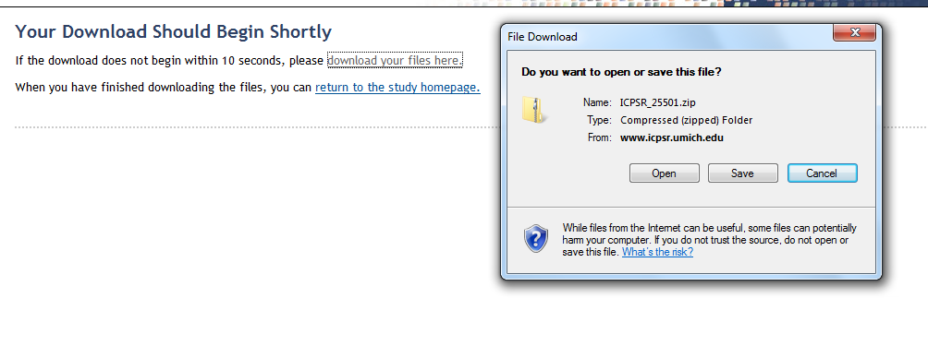
- When the download has finished, click “Open Folder”. Extract all files from the zip folder to the same location. Once the folder has been created, you can delete the zipped folder. The extracted files/folder should automatically open. Open the subsequent folders until you see two files: A “Data” (.txt) file and a “Setup” (.sps) file.
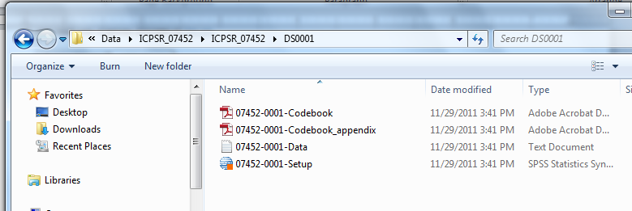
  - These two files have to be used in conjunction to open data in SPSS.
  - Keep this folder open to these files
- Double click on the SPSS Setup file, and the SPSS software will open an “Untitled” Data Window (the red icon) that is empty and a Syntax file (the orange icon) which is the setup file you will need.
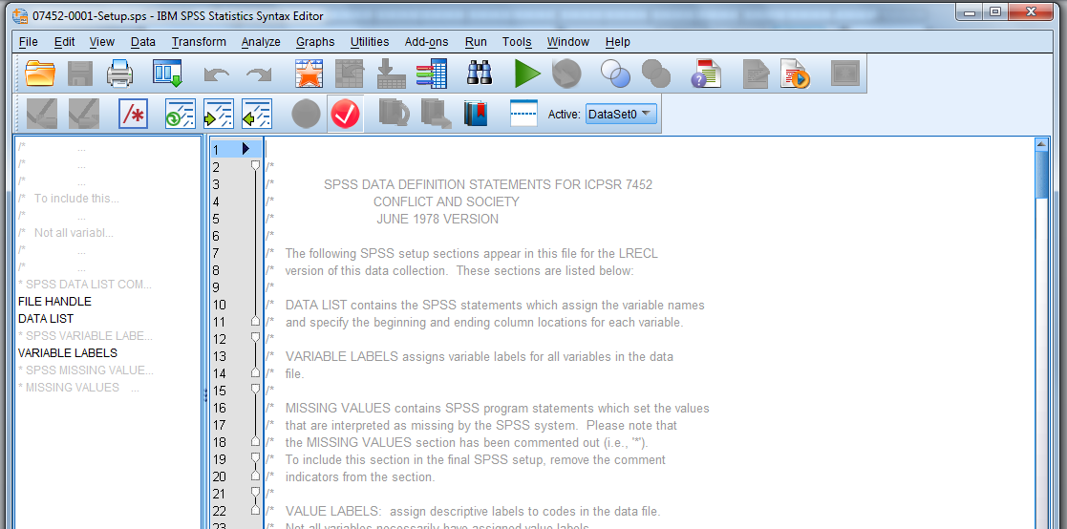

- Within the Syntax file, scroll down. You will see the list of Variable Names, a command with a list of Variable Labels. The third command is often time grayed out: “MISSING VALUES”. IF this is the case, delete the asterisk (*) before the phrase MISSING VALUES. The command and information that follows should no longer be grayed out.

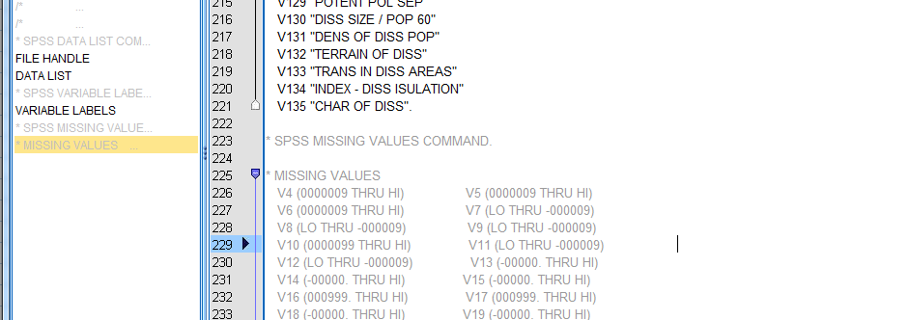
After asterisk deletion:
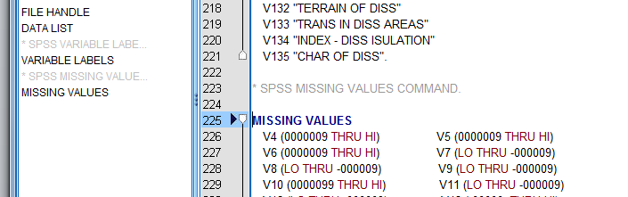
- Scroll back to where you can see the command “FILE HANDLE DATA / NAME="file-specification" LRECL=453.
- In place of what is in parentheses “file-specification” is where you must specific where your data is located. You will need to replace the words, file-specification, with the appropriate location.
- Go back to the open folder where you can see data and set-up files on your drive.
  - Click on, but do not open the “Data” or .txt file.
  - Go up to the “address bar” and click inside once. A blue highlight should appear showing and highlighting the file location of your Data file.

